UI for PhoneNumber Directory

1. List ALL phone numbers

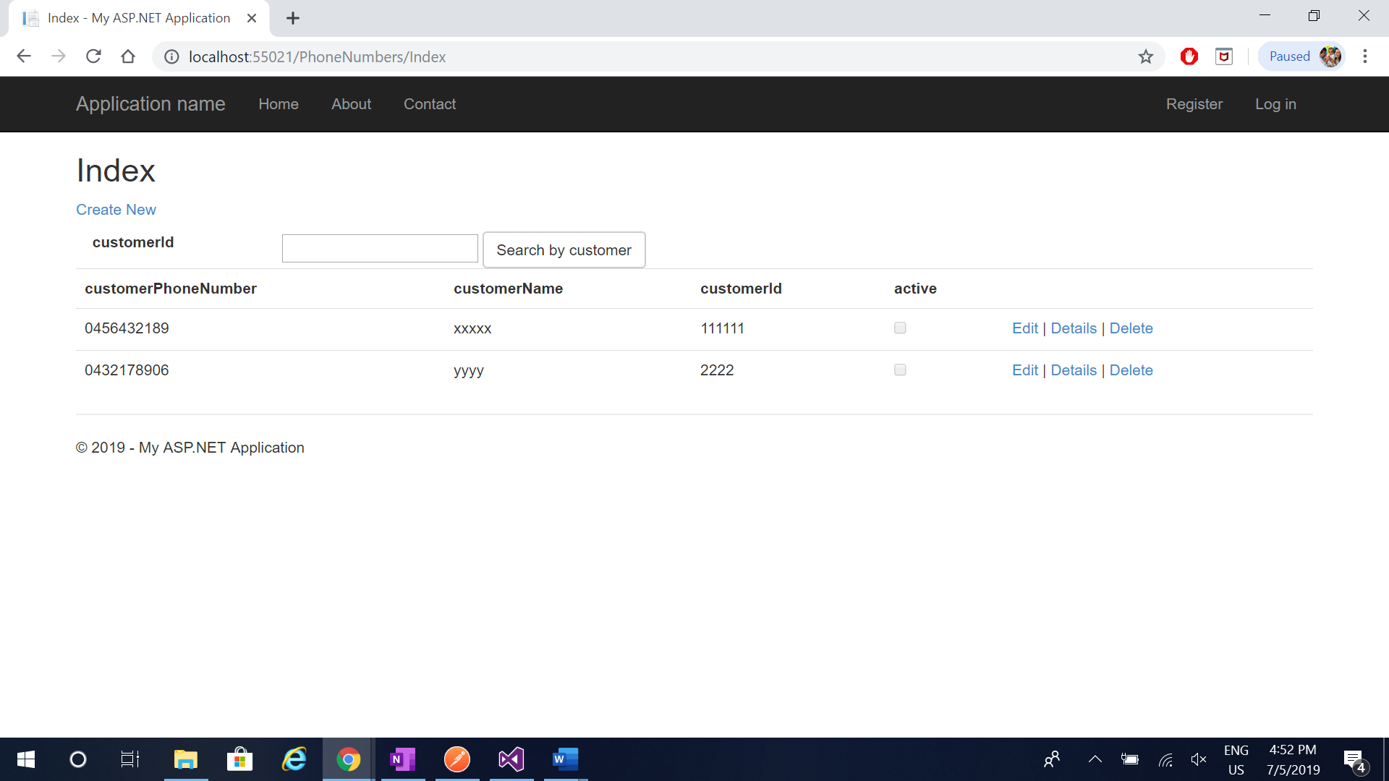

1. Create new record to store customer phone number

Click Create new link in the page

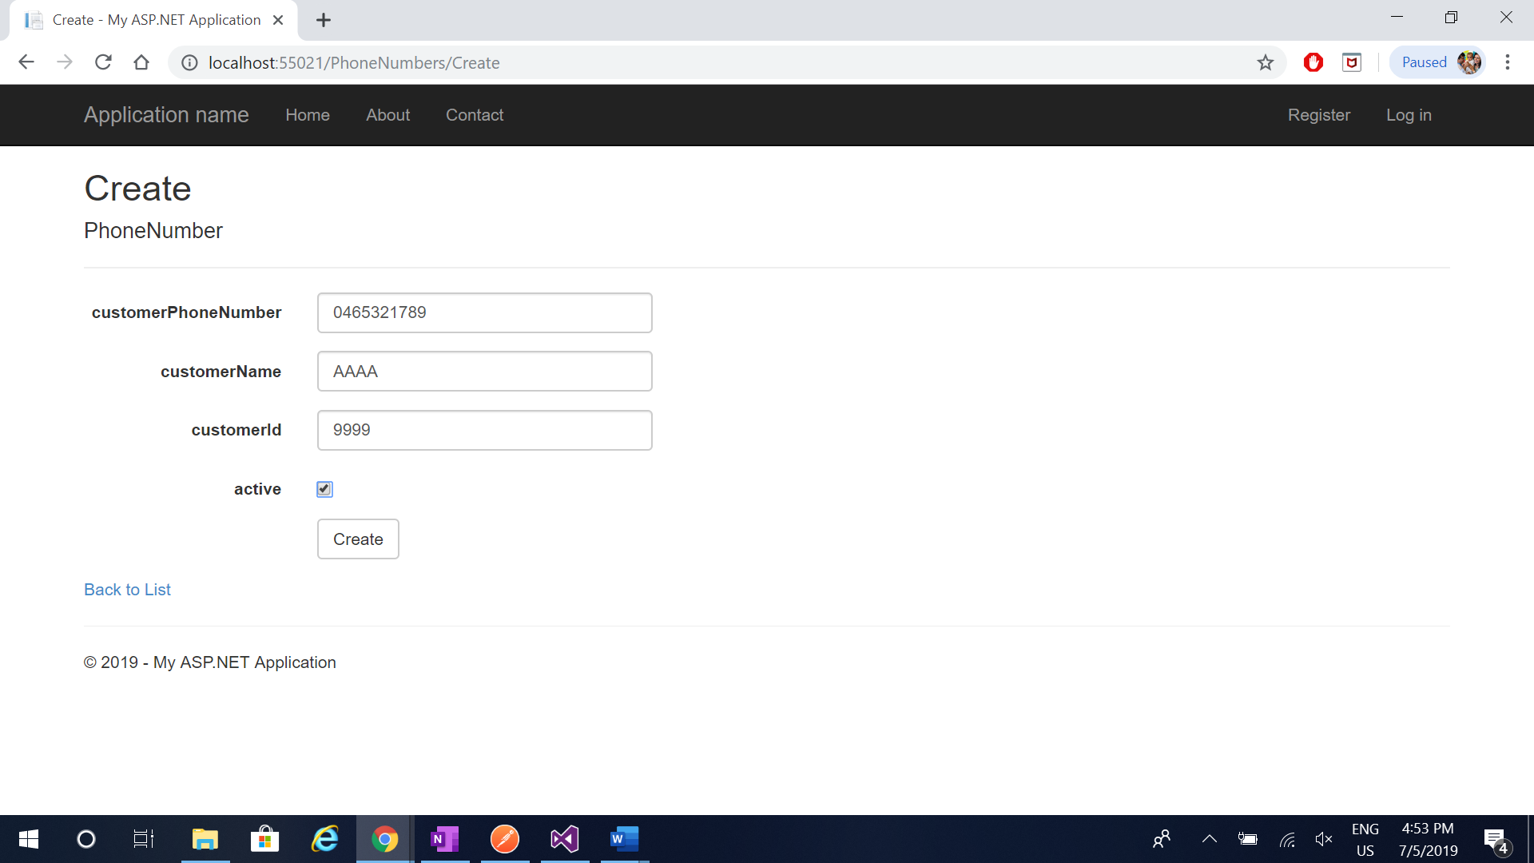

1. Activate customer phone number

Click Edit on record.

